Copy paste
4.3.3 Vulnerability Management
Vulnerability Management Life Cycle
According to NIST, vulnerability management is a security practice that is designed to proactively prevent the exploitation of IT vulnerabilities that exist within an organization. The expected result is to reduce the time and money spent dealing with vulnerabilities and the exploitation of those vulnerabilities. Proactively managing vulnerabilities of systems will reduce or eliminate the potential for exploitation and involve considerably less time and effort than responding after an exploitation has occurred.
Vulnerability management requires a robust means of identifying vulnerabilities based on vendor security bulletins and other information systems such as CVE. Security personnel must be competent in assessing the impact, if any, of vulnerability information they have received. Solutions should be identified with effective means of implementing and assessing the unanticipated consequences of implemented solutions. Finally, the solution should be tested to verify that the vulnerability has been eliminated.
Vulnerability Management Life Cycle
Image is a diagram of the Vulnerability Management Life Cycle. There are six small circles, arranged in a larger circle representing phases in the Vulnerability Management Lifecycle. Each circle is connected to the next by arrows pointing clockwise. The phases shown in the circles are Discover, Prioritize Assets, Assess, Report, Remediate, and Verify. The last arrow points back to the Discover phase.
Discover
Report
Remediate
Prioritize Assets
Assess
Verify
Vulnerability Management Life Cycle
expand_less
Discover
Inventory all assets across the network and identify host details, including operating systems and open services, to identify vulnerabilities. Develop a network baseline. Identify security vulnerabilities on a regular automated schedule.
expand_less
Prioritize Assets
Categorize assets into groups or business units, and assign a business value to asset groups based on their criticality to business operations.
expand_less
Assess
Determine a baseline risk profile to eliminate risks based on asset criticality, vulnerability, threats, and asset classification.
expand_less
Report
Measure the level of business risk associated with your assets according to your security policies. Document a security plan, monitor suspicious activity, and describe known vulnerabilities.
expand_less
Remediate
Prioritize according to business risk and address vulnerabilities in order of risk.
expand_less
Verify
Verify that threats have been eliminated through follow-up audits.
4.3.4 Asset Management
Asset management involves the implementation of systems that track the location and configuration of networked devices and software across an enterprise. As part of any security management plan, organizations must know what equipment accesses the network, where that equipment is within the enterprise and logically on the network, and what software and data those systems store or can access. Asset management not only tracks corporate assets and other authorized devices, but also can be used to identify devices that are not authorized on the network.
NIST specifies in publication NISTIR 8011 Volume 2, the detailed records that should be kept for each relevant device. NIST describes potential techniques and tools for operationalizing an asset management process:
- Automated discovery and inventory of the actual state of devices
- Articulation of the desired state for those devices using policies, plans, and procedures in the organization’s information security plan
- Identification of non-compliant authorized assets
- Remediation or acceptance of device state, possible iteration of desired state definition
- Repeat the process at regular intervals, or ongoing
The figure provides an overview of this process.
Figure is An operational concept for asset management with two textboxes at the top labeled collect current state of all authorized devices and specify desired state of devices. Each of these textboxes point to another textbox labeled find discrepancies in device state. This textbox points to another textbox labeled correct discrepancies, accept risk, or update policies. This last text box has arrows pointing back to each of the top two textboxes.
Collect Current State of all Authorized Devices
Specify Desired State of Devices
Find Discrepancies in Device State
Correct Discrepancies, Accept Risk, or Update Policies
4.3.5 Mobile Device Management
Mobile device management (MDM), especially in the age of BYOD, presents special challenges to asset management. Mobile devices cannot be physically controlled on the premises of an organization. They can be lost, stolen, or tampered with, putting data and network access at risk. Part of an MDM plan is acting when devices leave the custody of the responsible party. Measures that can be taken include disabling the lost device, encrypting the data on the device, and enhancing device access with more robust authentication measures.
Due to the diversity of mobile devices it is possible that some devices that will be used on the network are inherently less secure than others. Network administrators should assume that all mobile devices are untrusted until they have been properly secured by the organization.
MDM systems, such as Cisco Meraki Systems Manager, shown in the figure, allow security personnel to configure, monitor and update a very diverse set of mobile clients from the cloud.
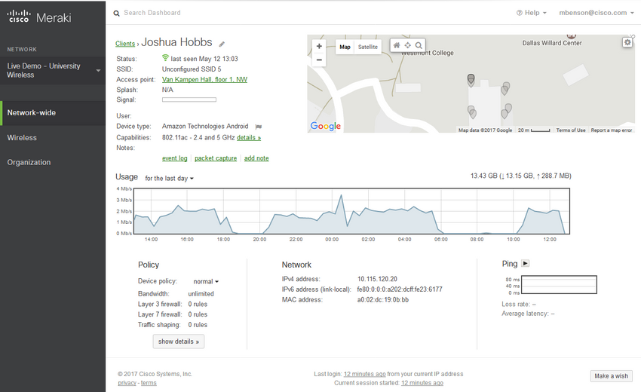
4.3.6 Configuration Management
Configuration management addresses the inventory and control of hardware and software configurations of systems. Secure device configurations reduce security risk. For example, an organization provides many computers and laptops to its workers. This enlarges the attack surface for the organization, because each system may be vulnerable to exploits. To manage this, the organization may create baseline software images and hardware configurations for each type of machine. These images may include a basic package of required software, endpoint security software, and customized security policies that control user access to aspects of the system configuration that could be made vulnerable. Hardware configurations may specify the permitted types of network interfaces and the permitted types of external storage.
Configuration management extends to the software and hardware configuration of networking devices and servers as well. As defined by NIST, configuration management:
Comprises a collection of activities focused on establishing and maintaining the integrity of products and systems, through control of the processes for initializing, changing, and monitoring the configurations of those products and systems.
NIST Special Publication 800-128 on configuration management for network security is available for download from NIST.
For internetworking devices, software tools are available that will backup configurations, detect changes in configuration files, and enable bulk change of configurations across a number of devices.
With the advent of cloud data centers and virtualization, management of numerous servers presents special challenges. Tools like Puppet, Chef, Ansible, and SaltStack enable efficient management of servers that are used in cloud-based computing.
4.3.7 Enterprise Patch Management
Patch management is related to vulnerability management. Vulnerabilities frequently appear in critical client, server, and networking device operating systems and firmware. Application software, especially internet applications and frameworks like Acrobat, Flash, and Java, also are frequently discovered to have vulnerabilities. Patch management involves all aspects of software patching, including identifying required patches, acquiring, distributing, installing, and verifying that the patch is installed on all required systems. Installing patches is frequently the most effective way to mitigate software vulnerabilities. Sometimes, they are the only way to do so.
Patch management is required by some compliance regulations, such as Sarbanes Oxley (SOX) and the Health Insurance Portability and Accountability Act (HIPAA). Failure to implement patches in a systematic and timely manner could result in audit failure and penalties for non-compliance. Patch management depends on asset management data to identify systems that are running software that requires patching. Patch management software is available from companies such as SolarWinds and LANDesk. Microsoft System Center Configuration Manager (SCCM) is an enterprise-level tool for automated distribution of patches to a large number of Microsoft Windows workstations and servers.
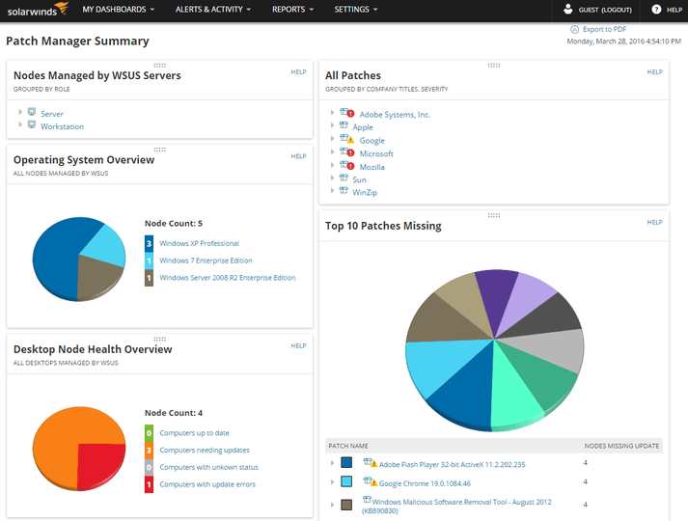
4.3.8 Patch Management Techniques
expand_less
Agent-based
This requires a software agent to be running on each host to be patched. The agent reports whether vulnerable software is installed on the host. The agent communicates with the patch management server, determines if patches exist that require installation, and installs the patches. The agent runs with sufficient privileges to allow it to install the patches. Agent-based approaches are the preferred means of patching mobile devices.
Figure shows agent-based with two clouds labeled vendor 1 patches and vendor 2 patches. Each cloud has an arrow pointing to a box that has a PC labeled caching device in it and the words security / I T team patch evaluation and testing in the bottom. An arrow goes from this box to the patch management server. 2 PCs, a laptop, and a mobile device have an agent installed and arrows pointing to and from the patch management server and each of these devices. The words host agent reports on patch status, server deploys and installs as required is bellows the devices.
Vendor 1 Patches
Vendor 2 Patches
Patch Management Server
Host agent reports on patch status, server deploys and installs as required.
Caching Device
Security/IT Team
patch evaluation and testing
expand_less
Agentless Scanning
Patch management servers scan the network for devices that require patching. The server determines which patches are required and installs those patches on the clients. Only devices that are on scanned network segments can be patched in this way. This can be a problem for mobile devices.
Figure shows agentless scanning with the same topology as agent-based, but the arrows are different. In this one all of the arrows are away from the patch management server pointing toward the four devices. The words are server detects patch status and installs as required.
Vendor 1 Patches
Vendor 2 Patches
Patch Management Server
Caching Device
Security/IT Team
Patch evaluation and testing
Server detects patch status and installs as required.
expand_less
Passive Network Monitoring

Chatgpt

Vulnerability Management — Simple Meaning
Vulnerability management means:
continuously finding and fixing security weaknesses before attackers exploit them.
Instead of:
waiting for attacks to happen,
organizations try to:
proactively detect and fix vulnerabilities.

Simple Analogy
Think of maintaining a building.
You:
- inspect cracks,
- repair broken locks,
- replace weak doors,
before thieves break in.
That is vulnerability management for computers.

Why it matters
Fixing problems early:
- costs less,
- saves time,
- prevents damage.
Fixing after an attack is much harder.

Vulnerability Management Life Cycle
This is a repeating cycle.

1. Discover
Find:
- devices,
- operating systems,
- services,
- vulnerabilities.
Example:
- detecting all laptops and servers in a company,
- finding open ports and outdated software.

“Develop a network baseline”
Learn:
what normal systems and behavior look like.
So unusual things can later be detected.

2. Prioritize Assets
Not all systems are equally important.
Example:
- payroll server = critical
- cafeteria display screen = less critical
Companies rank systems based on business importance.

3. Assess
Determine:
how risky the vulnerabilities are.
This considers:
- asset importance,
- threats,
- severity,
- exposure.
Example:
A critical vulnerability on a public banking server is high risk.

4. Report
Document:
- vulnerabilities,
- risks,
- suspicious activity,
- security plans.
Basically:
create security reports for teams and management.

5. Remediate
Fix the vulnerabilities.
Examples:
- install patches,
- close ports,
- remove insecure software,
- change configurations.
Higher-risk problems are fixed first.

6. Verify
Check whether fixes actually worked.
Example:
After patching:
- scan again,
- confirm vulnerability is gone.

Asset Management — Simple Meaning
Asset management means:
tracking all devices and software in an organization.
Companies must know:
- what devices exist,
- where they are,
- what software they run,
- what data they access.

Example
A company tracks:
- laptops,
- servers,
- routers,
- phones,
- installed software.

Why important?
You cannot secure:
devices you don’t know exist.
Asset management also helps find:
- unauthorized devices,
- rogue systems,
- unknown software.

NIST Asset Management Process

Collect Current State
Find what devices currently exist.
Example:
- installed software,
- OS versions,
- device configurations.

Specify Desired State
Define:
how devices SHOULD be configured.
Example:
- antivirus enabled,
- firewall enabled,
- approved software only.

Find Discrepancies
Compare:
- current state
vs
- desired state.
Example:
A laptop missing antivirus becomes a discrepancy.

Correct / Accept Risk / Update Policies
Then:
- fix the issue,
- accept the risk,
- or change policies.

Mobile Device Management (MDM)
MDM means:
managing and securing phones/tablets used in an organization.
Especially important in BYOD:
Bring Your Own Device.

Why mobile devices are risky
Phones can:
- be lost,
- stolen,
- tampered with.
This risks:
- company data,
- network access.

Example Security Measures
If a phone is lost:
- remotely disable it,
- erase data,
- require stronger login authentication.

“Treat mobile devices as untrusted”
Admins assume:
mobile devices are insecure until verified.
Because different devices have different security levels.

Cisco Meraki Systems Manager
An MDM tool that helps admins:
- configure devices,
- monitor devices,
- update devices remotely from the cloud.

Configuration Management — Simple Meaning
Configuration management means:
controlling and standardizing device/software settings.
Goal:
keep systems securely configured.

Example
A company may define:
- approved software,
- required antivirus,
- allowed USB devices,
- allowed network adapters.
Every employee laptop follows the same secure setup.

Why important?
Without standard configurations:
- systems become inconsistent,
- vulnerabilities increase,
- attack surface grows.

“Baseline images”
A baseline image is:
a preconfigured standard system setup.
Example:
Every new employee laptop comes with:
- Windows,
- antivirus,
- company security settings,
- approved software.

Networking Device Configuration Management
Admins also manage:
- router configs,
- switch configs,
- firewall configs.
Tools can:
- backup configurations,
- detect changes,
- update many devices at once.

Cloud Server Management Tools
Tools like:
- Puppet
- Chef
- Ansible
- SaltStack
help automate server configuration management.
Especially useful for:
- cloud infrastructure,
- many servers,
- virtualization.

Enterprise Patch Management — Simple Meaning
Patch management means:
managing software updates/security fixes.

Why patches matter
Software often has vulnerabilities.
Examples:
- browsers,
- operating systems,
- Java,
- Flash,
- servers.
Patches fix these vulnerabilities.

Patch Management Tasks
Includes:
- finding required patches,
- downloading patches,
- testing patches,
- installing patches,
- verifying installation.

Why important?
Sometimes:
patching is the ONLY fix for a vulnerability.

Compliance Regulations
Some laws require patch management.
Examples:
- SOX
- HIPAA
Failure to patch systems properly can:
- fail audits,
- cause penalties.

Dependency on Asset Management
Patch management needs asset management because:
you must know which systems need patches.

Patch Management Tools
Examples:
- SolarWinds
- Microsoft System Center Configuration Manager
These automate patch deployment.

Patch Management Techniques

1. Agent-Based
Each device has a small software agent installed.
The agent:
- checks patch status,
- talks to patch server,
- installs updates.

Example
Laptop agent reports:
“Chrome outdated.”
Patch server sends update automatically.

Why good for mobile devices?
Because mobile devices may not always stay on company networks.
Agents can still communicate remotely.

2. Agentless Scanning
No software agent on devices.
Instead:
- patch server scans the network,
- finds vulnerable systems,
- installs patches remotely.

Limitation
Works mainly for:
devices currently reachable on the network.
Problematic for:
- remote laptops,
- disconnected devices.

Difference Between Agent-Based and Agentless
Method | How It Works
Agent-Based | Device has installed agent software
Agentless | Server scans devices remotely

